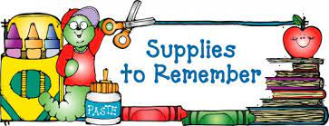

Third Grade

* 1 pkg. pencil top erasers
* 1 16 oz. bottle of glue or glue sticks
* 4 composition notebooks (wide-ruled)
* 5 spiral notebooks
* 2 folders with prongs and pockets
* 2 pks. loose leaf wide-ruled notebook paper
* 1 pair of noise cancelling headphones or earbuds
* 1 box of colored pencils (16 count)
* 1 box of crayola crayons (24 count)
* 1 box of tissue
* 1 pack of index cards
* 1 pack of Expo dry erase markers (narrow tip, multiple colors)
* scissors
* ruler
* 1 pencil box
* 1 covered pencil sharpener
* 1 small dry eraser
* pencils 48 (bring 2 each day)